Screenshots or program listings must be copied into appropriate cells in the following table.
Save this evidence document as evidence_ followed by your centre number_ candidate number, for example, evidence_ zz999_9999 and insert your name, candidate number and centre number into the header above.
Examiners must be able to read the contents including any screenshots without the use of a magnifying glass. Answers that are not readable or are missing will not be awarded any marks.
Save this evidence document at regular intervals, for example every 10 minutes.
Question 1
Part 1(a)(i)
def IterativeVowels(Value):
total = 0
LengthString = len(Value)
for x in range(LengthString):
FirstCharacter = Value[0: 1]
if FirstCharacter in ['a', 'e', 'i', 'o', 'u']:
total += 1
Value = Value[1:]
return total

Part 1(a)(ii)
def main():
print(IterativeVowels("house"))

if __name__ == "__main__":
main()

Part 1(a)(iii)

Part 1(b)(i)
def RecursiveVowels(Value):
LengthString = len(Value)
if LengthString == 0:
return 0
for x in range(LengthString):
FirstCharacter = Value[0: 1]
if FirstCharacter in ['a', 'e', 'i', 'o', 'u']:
return 1 + RecursiveVowels(Value[1:])
else:
return RecursiveVowels(Value[1:])

Part 1(b)(ii)
def main():
print(RecursiveVowels("imagine"))

if __name__ == "__main__":
main()

Part 1(b)(iii)

Question 2
Part 2(a)(i)
global Queue
Queue = [""] * 50
global HeadPointer
HeadPointer = -1
global TailPointer
TailPointer = 0

Part 2(a)(ii)
def Enqueue(s):
global TailPointer, HeadPointer
if TailPointer - HeadPointer > 50:
print("The queue is full.")
return
if Queue[0] == "":
HeadPointer = 0
Queue[TailPointer] = s
TailPointer += 1
Return

Part 2(a)(iii)
def Dequeue():
global TailPointer, HeadPointer
if TailPointer == HeadPointer:
print("The queue is empty.")
return "Empty"
tmp = Queue[HeadPointer]
Queue[HeadPointer] = ""
HeadPointer += 1
return tmp

Part 2(b)
def ReadData():
try:
with open("QueueData.txt", encoding = 'utf-8') as f:
for line in f:
Enqueue(line.strip())
except IOError:
print("File not found.")

Part 2(c)(i)
class RecordData:
def __init__(self, ids, total):
self.ID = ids #string
self.Total = total #integer

Part 2(c)(ii)
global Records
Records = [None] * 50 #array of RecordData
global NumberRecords
NumberRecords = 0 #integer

Part 2(c)(iii)
def TotalData():
global NumberRecords, Records
DataAccessed = Dequeue()
Flag = False
if NumberRecords == 0:
Records[NumberRecords] = RecordData(DataAccessed, 1)
Flag = True
NumberRecords += 1
else:
for x in range(0, NumberRecords):
if Records[x].ID == DataAccessed:
Records[x].Total += 1
Flag = True
if Flag == False:
Records[NumberRecords] = RecordData(DataAccessed, 1)
NumberRecords += 1

Part 2(d)
def OutputRecords():
global Records
i = 0
while Records[i] != None:
print(f"ID {Records[i].ID} Total {Records[i].Total}")
i += 1

Part 2(e)(i)
def main():
global TailPointer, HeadPointer, Records
ReadData()
for i in range(TailPointer - HeadPointer):
TotalData()
OutputRecords()

if __name__ == "__main__":
main()

Part 2(e)(ii)
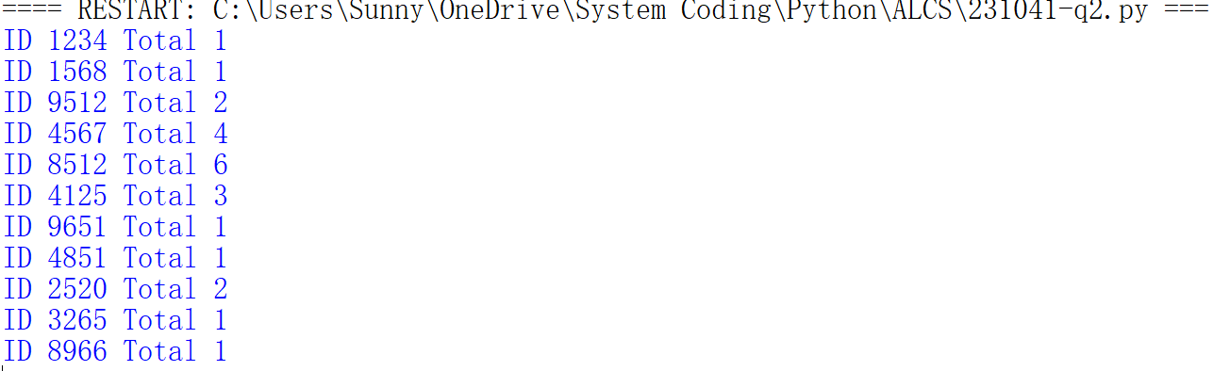

Question 3
Part 3(a)(i)
class Character:
def __init__(self, name, x, y):
self.Name = name
self.XPosition = x
self.YPosition = y

Part 3(a)(ii)
def GetXPosition(self):
return self.XPosition
def GetYPosition(self):
return self.YPosition

Part 3(a)(iii)
def SetXPosition(self, x):
self.XPosition = min(max(x,0), 10000)
def SetYPosition(self, y):
self.YPosition = min(max(y,0), 10000)

Part 3(a)(iv)
def Move(self, s):
if s.lower() in ['up', 'down', 'left', 'right']:
if s == 'up':
self.SetYPosition(self.GetYPosition() + 10)
elif s == 'down':
self.SetYPosition(self.GetYPosition() - 10)
elif s == 'left':
self.SetXPosition(self.GetXPosition() - 10)
else:
self.SetXPosition(self.GetXPosition() + 10)
else: print("Should be left, right, up, or down.")

Part 3(b)
def main():
Jack = Character("Jack", 50, 50)
if __name__ == "__main__":
main()

Part 3(c)(i)
class BikeCharacter(Character):
def __init__(self, name, x, y):
Character.__init__(self, name, x, y)

Part 3(c)(ii)
def Move(self, s):
if s.lower() in ['up', 'down', 'left', 'right']:
if s == 'up':
self.SetYPosition(self.GetYPosition() + 20)
elif s == 'down':
self.SetYPosition(self.GetYPosition() - 20)
elif s == 'left':
self.SetXPosition(self.GetXPosition() - 20)
else:
self.SetXPosition(self.GetXPosition() + 20)
else: print("Should be left, right, up, or down.")

Part 3(d)
Karla = BikeCharacter("Karla", 100, 50)

Part 3(e)(i)
def main():
Jack = Character("Jack", 50, 50)
Karla = BikeCharacter("Karla", 100, 50)
n = ""
while n.lower() not in ["jack", "karla"]:
n = input("Which character to move? Jack or Karla: ")
d = input("Which direction do you want to move: ")
if n.lower() == "jack":
Jack.Move(d)
print(f"Jack's new position is X = {Jack.GetXPosition()} Y = {Jack.GetYPosition()}")
else:
Karla.Move(d)
print(f"Karla's new position is X = {Karla.GetXPosition()} Y = {Karla.GetYPosition()}")

if __name__ == "__main__":
main()

Part 3(e)(ii)
